A multinational organization expanding into a new country: A perspective of International HRM
Name
Institution
Date

Executive summary
Organizations aimed to study how a multinational organization expands (C&R) into a new country (Malaysia) by focusing on the perspective of International HRM. Most companies have also implemented business intelligence processes as an ERP system extension for gaining greater insight into business transactions and processes (Shen, Chen, & Wang 2016). Notably, business-related information is gathered analysed and stored in ERP systems for future retrieval and reports generation. Additionally, using business intelligence, information stored can be analysed and synthesized to suit the various needs of an organization in decision making. Such information is considered essential in creating competitive advantages for companies in this dynamic business environment.
To achieve the global sustainability strategy, C&A developed three pillar areas that have the most significant impact on their business; sustainable products, sustainable supply, and sustainable lives. C&A should penetrate to the Malaysian market to enhance its global market share and profitability. There are roughly over 795 Small and Medium Enterprises (SME) in the Malaysian textile industry. The market has a vast potential and is expected to grow to 154% by 2020. The country enjoys sophisticated textile systems but may end up failing due to the lack of knowledgeable and skilled labour.
The shortage of skilled workforce is hindering the growth of the textile industry because many of the textile manufacturers shy away from committing to recurring orders to avoid setbacks due to labour shortage (Udriyah, Tham, &Azam 2019). Given the high costs of labour, C&A should be penetrating the Malaysian market by establishing online sales as well as establishing retail stores in the Malaysian market. The discouraging costs of the workforce offer the company the opportunity to import textiles and apparel to the Malaysian market from other countries with lower production costs like China, Sri Lanka, Cambodia, and India.

A multinational organization expanding into a new country: A perspective of International HRM

- Introduction
In today's world, companies have come to recognize the importance of offering timely, accurate, and relevant information that facilitates their personnel to engage in effective decision making effectively. According to Altamony et al. (2016), information is very critical and provides the organization with the glue to hold the business together. Most companies have established information systems that help in the collection, processing, and sharing of information among various stakeholders within an organization. One such critical system is Enterprise Resource Planning (ERP) that has revolutionized resource allocation effectively by integrating and standardizing business processes and transactions.
ERP is exceptionally critical in most corporates because it enhances a company's competitiveness in today's business world and provides the basis for future growth. Most companies have also implemented business intelligence processes as an ERP system extension for gaining greater insight into business transactions and processes (Shen, Chen, & Wang 2016). Notably, business-related information is gathered analysed and stored in ERP systems for future retrieval and reports generation. Additionally, using business intelligence, information stored can be analysed and synthesized to suit the various needs of an organization in decision making. Such information is considered essential in creating competitive advantages for companies in this dynamic business environment.
The retail industry, for instance, has faced considerable changes due to changing regulatory environment, competition, the introduction of advanced technologies, and renewable retail. The changing environment increases the need for organizations to create a cohesive decision making process in response to external competitive pressures. This research centres on business intelligence and the development of strategies in Human Resource Management (HRM) by a giant retail company, C&A. However, the strategic approach and findings can be applied to other retail companies as well as other industry sectors.
- Company Background
C&A is a Dutch global pioneer in the fashion business bosting over 170 years in the market. The company, which initially started in the 1600s as a textile company, has grown through turbulent and prosperous times to get to where it is today. C&A has been a family business over six generations and continues to innovate and adapt to the global changing business environment. In 1841, the two brothers, Clemens and August, coined the name C&A by abbreviating their names. The company's commitment to ensuring customer satisfaction has not changed over the centuries and continues to drive transformations in the fashion industry. Their head offices are located at Vilvoorde in Belgium and Düsseldorf in Germany. It has a chain of retail stores across Europe, Asia, Central, and South America. The company brands range from Canda, Clockhouse, Palomino, Angelo Litrico, Here+there, Yessica, Your sixth sense, Westbury, Yessica Pure, and Rodeo.
The company began discounting in 1906 in Amsterdam, and by 1910 the company had already established ten stores in the Netherlands. For a good number of years now, C&A retail stores have been of significant presence in the high streets of the United Kingdom.
In the 1990s, C&A engaged in the implementation of SAP's ERP system, mainly, the Enterprise Asset Management functionality aimed at addressing the business change needs. The company later added more functionality systems by extending the ERP modules such as work and Asset management, Logistics, Accounting, Resource Planning and scheduling, and the Human Resource module. The implementation of the ERP system led to significant benefits like improvement in employee productivity, enhanced inventory management, and improved decision making by management.
Even after implementing the ERP system, the company sometimes found it difficult to retrieve crucial reporting information needed for decision making support. This was because the company had not replaced all its internal systems with the ERP system (Altamony et al., 2016). They needed to integrate existing systems with the new ERP system to allow smooth reporting processes. The company subsequently acquired the Business Warehouse (BW) and SAP to help address the current problem. The integration was not ultimately successful because the company had acquired SAP before BW; hence, the company still faced the same reporting issues.
In 2008, the company embarked in a plan to create an Information Management System that was pinned to Business Intelligence. The goals of the strategy were to create a single Enterprise Data System that would allow the storage and analysis of both strategic and operational activities. Besides, the system was meant to streamline reporting so that only intelligent and relevant information was reported for financial planning, forecasting, and consolidation. Additionally, it allowed only the right information to be shared at the right time to the right people by retiring the Business Warehouse to reduce IT costs and consolidate reporting systems (Shen, Chen, & Wang 2016). The information system consisted of six components that allowed the accommodation of interdependent elements that included information hierarchy, technology issues, application issues, business intelligence architecture, reporting strategies, and the governance model. For the purpose and relevance of this report, the study discusses the information hierarchy component.
The information hierarchy component was designed to ensure and address information needs for all stakeholders. Information was arranged in a top-down approach by strategically aligning the level of management with the information requirements as well as performance measures. Performance measures were critical in improving accountability and visibility that leads to a change in staff behaviour. The key information requirement definitions were for performance management meant for business growth, and the operations and decisions support information for managing business operations.
Performance measurement through performance management information supported value-based management and utilized a balanced scorecard approach. The performance information was aggregated for decision making by top-level management (Altamony et al., 2016). Performance measurement is strongly reliant on the availability and reliability of the data to arrive at the desired measures. Necessary changes were also made in management processes to ensure all personnel clearly understood performance expectations. Staff appraisals, compensation, and rewarding schemes were established to achieve the desired change in organizational behaviour, business processes, and technology support.
- Corporate Strategy
C&A aims to mainstream sustainability in the fashion clothing industry to become the new normal. The company intends to influence customer's trust to purchase the company products by convincing them of their commitment to transparency, respect to people, and environmental conservation. In 2015, C&A developed its first global sustainability strategy that entails the embedment of sustainability in business operations and the global retail market leadership (Hickman & Silva2018). In addition to the global alignment goals, C&A provides flexibility in goal achievement in meeting local stakeholder needs through innovation. To achieve the global sustainability strategy, the company developed three pillar areas that have the most significant impact on their business; sustainable products, sustainable supply, and sustainable lives.
Sustainable products
In ensuring sustainable products, the company does not intend to pose customers with the challenge to choose between sustainable and non-sustainable products; instead, they are committed to ensuring the entire designed and sourced clothing meet the sustainability criteria. In arriving at this goal, C&A is focusing in ensuring sustainable materials are used in the manufacture of internal and outsourced clothing to guarantee respect to animals, the environment, and people by 2020. Cotton, for instance, forms the bulk of materials used in the company's clothing. The company is also collaborating with other players in the industry to ensure a collaborative movement in creating innovative and sustainable products.
Sustainable supply
The supply for C&A's apparel is very complicated. The company runs over 1,600 production units with more than 722 global suppliers that have directly or indirectly employed over one million employees. More so, the company supply chain starts from agriculture with the sourcing of water and raw materials. This explains why the supply chain is so critical to the company's sustainability agenda. The company is focused in ensuring sustainable agriculture and promotes environmental and social sustainability in the supply chain by revolutionizing the production system using technology (Hawking &Sellitto2018). By 2020, C&A is committed to ensure zero discharge of harmful chemicals, a 20% reduction in CO2 emissions in C&A offices, distribution centres and stores, reduce water use by 30%, and nil landfill waste.
Sustainable lives
The sustainable lives strategy for C&A is driven by the fact that the company directly employs 51,000 employees. Through the Apparel supply chain, the company touches the lives of over one million workers and over 100 million customers every year. As a result, everything the company does have a direct impact on the lives of these people. Therefore the company is focusing on ensuring the empowerment of customers in making sustainable shopping decisions. Besides, the company is inclined to supporting supply chain workers by engaging the company employees as sustainability ambassadors.
- Economic Drivers
Economic drivers are the internal or external company factors that influence its overall market environment. These factors are available in different economic levels. Microeconomic factors cause changes in the global market environment, while microeconomic factors cause changes at the company level (Franco 2017). A microeconomic driver could have a material impact on the company earnings or stock price. C&A should penetrate to the Malaysian market to enhance its global market share and profitability. There are roughly over 795 Small and Medium Enterprises (SME) in the Malaysian textile industry. The market has a huge potential and is expected to grow to 154% by 2020. Compared to other South Asian countries, textile exports are considerably low, and they form approximately 2% of total exports. SMEs are struggling to improve on output due to lack of adequate labour skills, management skills, and capital investment. With over 170 years of operation in the textile and apparel industry, C&A has the requisite tools to succeed in the Malaysian market. The company possesses the needed technology, human capital, and financial capital to set up a production unit in Malaysia. The success achieved in China in such a short time should drive C&A to establish more production units or sales stores in Asia to create a competitive advantage to enhance revenues and improve market share.
- PESTEL Analysis
The Malayisan political environment is fairly stable with the Barisan National Party having been in power for over 25 years. This ensures a consistent business environment for C&A to invest in the country (IDRIS and RAHMAN 2019). Corruption also exists in Malaysia which ranks 47th according to transparency international.
The Malaysian economy is on a growth trajectory posting an annual growth averaging 7%. Such economic growth rate translates to increasing income and purchasing power. The country also enjoys a healthy current account with exports accounting for 37% of national GDP.
There are three major social compositions in the Malaysian market; Malay account for 60% of the country’s population, Chinese 10% and Indians 10%. The sociocultural composition portrays a vibrant and harmonious environment for business growth. The country is mostly Muslim with Malays bound by Muslim law while the others are at liberty to practice any other religion (IDRIS and RAHMAN 2019). Business entering this market needs to design products that meet the diverse population needs.
Malaysia strives to enhance technological adoption with the country needing to grow technologically to compete internationally. The country established a Multimedia Super Corridor (MSC) that hosts 360 multinationals both local and foreign focused on communication and multimedia products (Swan et al. 2018). Malaysia continues to attract world’s best ICT companies to power technological expansion. They have invested in research, education and infrastructure by creating a Cyberjaya town which boasts ICT infrastructure of world-class status. this makes Malaysia an attractive destination for C&A.
Malaysia legal system is founded on the British common law although Islamic laws are widely applied too. Any company investing in Malaysia needs to familiarize with these laws to ensure fair application and treatment.
To a large extent, the Malaysian environment has suffered due to rapid development. The rate of deforestation is considered the highest in any tropical country which loses approximately 0.65% of its rain forests every year (IDRIS and RAHMAN 2019). The destruction of wildlife habitats has seen the country face criticism hence foreign companies investing in the country need to exercise caution to avoid protests and demonstrations.

- Mode of Entry
Given the high costs of labor, C&A should penetrate the Malaysian market by establishing wholly owned online sales and retail stores in the Malaysian market. The discouraging costs of human resources offer the company the opportunity to import textiles and apparel to the Malaysian market from other countries with lower production costs like China, Sri Lanka, Cambodia, and India. It shall also relief the company from a large capital outlay needed to set up a manufacturing plant.
The foreign labour practice in the Malaysian textile and garment industry, which is regulated by the government, exposes the manufacturers to future labour uncertainties that could adversely affect any labour reliant manufacturing entity. The industry is labour intensive and requires labour to run smoothly. As a result, some manufacturers in Malaysia have establishments in countries with cheaper labour to reduce on costs of production (Crinis2017). Other operators like Puma have established vertical supply chains by producing garments in neighbouring countries like Cambodia, where labour is cheaper.
- HRM Model
C&A applies the Harvard Human Resource Management model. The HRM framework is adopted due to its holistic nature to HR as well as showing different outcome levels. Firstly, the model consists of six essential business components; stakeholder interests, situation factors, HR outcomes, HRM policy choices, long-term consequences, and feedback the flow from the external environment to the organization stakeholders (Sato, Kobayashi, &Shirasaka 2017).
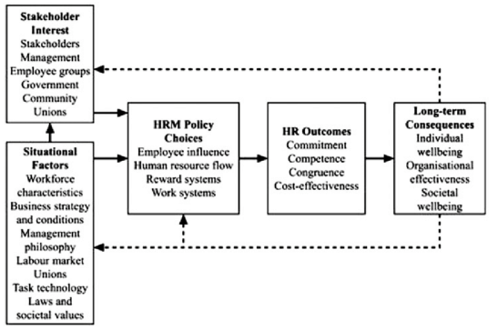
Figure 1: The Harvard HRM model
Stakeholder interests are the critical component of the model. To ensure sustainable global market leadership, C&A has continued to ensure compliance with worldwide business and labour regulations. The company's sustainable lives strategy reflects the company's priority in managing sustainable stakeholder interests. As a result, C&A is focusing on ensuring the empowerment of customers in making sustainable shopping decisions. Also, the company is inclined to supporting supply chain workers by engaging the company employees as sustainability ambassadors.
The situational factors, on the other hand, influence the stakeholders' interests, which subsequently affect the HR policies at C&A. The company faces significant pressure from within and outside the company, such as employee influence in terms of the authorities, responsibilities, and power delegation to employees from management. These influences have been in a way that they are compatible with the purpose and priorities of the company. The company has aligned personnel specialists and management who are competent as per the Harvard Model to deliver on its strategic objectives. This has been achieved through the company's exemplary management of the recruitment, promotion, employment termination, and career advancement processes.
The company has an extrinsic and intrinsic reward system that ensures proper compensation and benefits, health insurance, pension holiday entitlement, bonuses, flexible working environment, and working hours. The Harvard model calls for the active involvement of employees in designing the rewarding system; however, besides meeting the needs of employees, the final decision has been consistent with HRM policies, business strategy, and management policy. C&A has utilized work systems that include information, technology, activities, and people by arranging them at all organization levels to allow effective and efficient work performance.
In adhering to the philosophies of the Harvard, the HR model company has been able to ensure high levels of staff commitment, congruence, and competence, and cost-efficiency. For instance, C&A has overtime maintained a below-average staff turnover rate.
- Culture Challenges

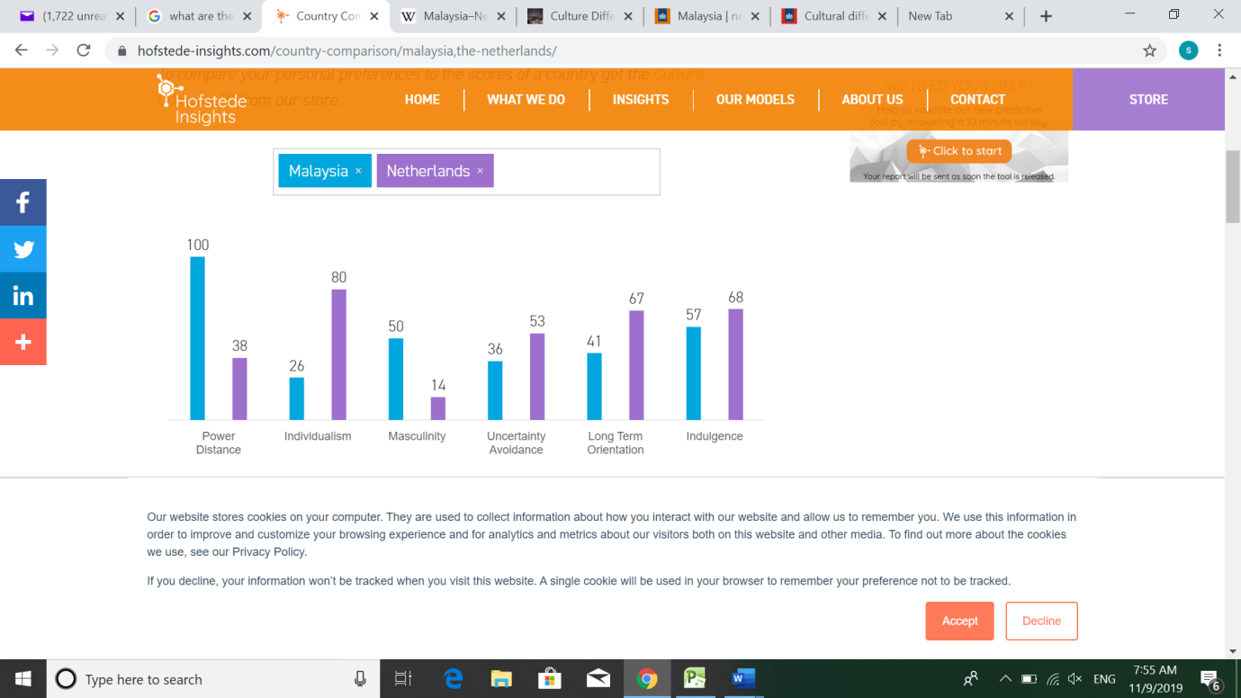
Figure 2: Cultural comparison between Malaysia and Netherlands
Given the international market presence of C&A across Europe, Asia, Central, and South America, the country faces several cultural challenges in its day to day operations within its current markets and while penetrating new markets. It is the goal of C&A to ensure sustainability as a norm for both customers and employees. The company aims to ensure customers have a super experience while shopping at C&A stores while ensuring employees feel valued for their contributions to the organization.
This part uses 6D model to explore the Malaysian culture in relation to the rest of the world. Malaysia uses a hierarchical order that means everyone has a place in the society. As a result inequalities are evident and centralization is common with subordinates expected to be told what to do. Challenging the authority of leadership is not taken lightly.
The interdependence among the Malaysian population is high whether in family or extended relationships. Loyalty is a valuable virtue and scores higher than social regulations and rules. The culture foster mutual relationships that means taking responsibility for fellow members. Relationships between employee and employer are perceived as family ties hence employees and management are regarded in mutual groups.
In masculinity terms, Malaysia ranks average and cannot be decided whether the culture is feminine or masculine. There are no dominant players here and everyone is responsible to deliver. Standing out alone is not admirable rather the success of a group is preferred.
Malaysia deals with uncertainty by maintaining necessary rules and avoiding ambiguous and nonworking rules to maintain a flexible environment that harbour innovation and deviation of the normal.
Long-term orientation ensures people maintain a connection with the past, present and the future in setting goals and making decisions. A low score of 41 indicate a normative culture with strong believes in the absolute truth in working and thinking. The Malaysians focus in achieving fast results and hold high regards for traditions.
In terms of indulgence, the country is moderately indulgent with a score of 57. The society is considered to have fun and enjoy life with a positive attitude and high levels of optimism.
- Recruitment and Selection process
In entering the Malaysian market, C&A will need to establish a team that would run the Malaysia subsidiary. This will require a set of operational and management staff. Since the store will only sell clothing and apparels without manufacturing them they will need the following members of staff to run operations.
Function | Number of positions | Home country (HCN)/ Parent Company (PCN)
Chief Executive Officer | 1 | PCN
Chief Finance Officer | 1 | PCN
Assistant Finance manager | 1 | HCN
Marketing Head | 1 | PCN
Assistant Marketing Manager | 1 | HCN
Marketing Officers | 4 | HCN
Sales Executives | 10 | HCN
Fashion designers | 3 | HCN
Customer Service | 2 | HCN
Cashiers | 3 | HCN
Store manager | 1 | HCN
IT support | 2 | HCN
Figure 3: Job positions in Malaysia
  - Source of External Recruitment
All available job opportunities are typically displayed on the company website at the careers section, whether a job seeker wants to work as designers, IT, or as sales assistants within branches of at any other capacity at the company's head offices. Once a potential employee identifies the suitable job, the next step includes applying for the post by clicking on the apply link then completes a standardized application form before uploading other application documents. When C&A receives a job application, a prompt confirmation of receipt message is relayed back to the sender. Standard review of job applications takes four weeks, after which shortlisted individuals are called for an initial introductory phone call then invited for a face to face interview.
Further details about the job are shared at this stage, and depending on the level of entry or department, the job seeker is invited for a subsequent interview or asked to attend the company's assessment centre. Upon being satisfied by the interviewee, the company makes a formal job offer. If satisfied with the offer, the job seeker becomes a new member of staff, and preparations for the first day at work begin.
  - Source of Internal Recruitment
Rodger's seven-point recruitment plan model is critical in matching the job description and the job applicant. The seven points considered during recruitment, according to Rodger, include physique, qualification and experience achievements, logical capability, special aptitudes, extra-curricular activities, disposition and flexibility, and adaptation. During recruitment, it is essential to prioritize vitally and desired applicant characteristics before starting the selection process. C&A being a multinational company with a diverse cultural environment emphasizes more on the applicant's work attitudes and skills. This helps the company avoid the application of a biased selection process that can complicate the selection process.
- Training and Development
C&A prides itself in ensuring sustainability in all its business engagements. As a result, the company engages and empowers its employees in sustainability matters about their region (Zarceno 2017). The store staffs are essential ambassadors of the company's sustainability strategy, making them particularly important in the training programs. Internal engagements and communications are shared to store staff during customer-facing campaigns to ensure the information is relayed to customers. C&A supports staff personal and career development by providing an e-learning platform at the workplace and offers core topics for learning as well as management development programs that provide additional training to managers with both potential and outstanding performance.
For new staff, the company C&A Europe provides a monthly orientation plan that ensures familiarization with the business environment and the company's actions and commitments to sustainability. C&A China and Brazil launched a company-wide online training platform and corporate education platform, respectively, in 2017 to supplement the training needs of the company staff.
Below is a table showing training and development of a Fashion Designer using the ADDIE model:

Analysis | Designers to understand the needs, values and characteristics of customers  Designers to design products as per the C&A standards
Design | Understanding of existing fashions and trend is key  Hand-on support training will be necessary
Development | Fashion designers from Head office will be flown to Malaysia to train new designers
Implementation | Necessary supportive fashion training material will be availed  Rights to designing programs will be given
Evaluation | Designer familiarity with fashion designs and trend is determined  Competency designing level and further support needed will be determined.
Figure 4: Training and Development using ADDIE Model
- Performance Management and Appraisal
Changing environmental needs are forcing contemporary organizations to transform to excel in business through proactive change managing an adaptive capability building (DeNisi& Murphy, 2017). Traditional methods did not put into consideration the dynamic nature of the business environment instead used subjective performance indicators and behavioural attributes in evaluating performance.
  - Performance Management
Performance management involves the identification, measurement, management, and development of the performance of personnel in and organization. The performance management cycle is a four-step procedure that requires planning, monitoring, reviewing, and rewarding. Traditionally the model runs for one year ending with a review (Soesanto et al., 2016). C&A practices this traditional one-year performance management model where performance planning is done at the start of the year when performance targets for the year are set using a balanced scorecard. Across the year, actual performance is shared with respective staff on a monthly and quarterly basis to allow performance monitoring.
The interim sharing of performance enable employees to know areas that they are doing well as well as area the need more focus. Performance reviews are conducted at the end of every month and quarter and year to track the progressive performance of staff and determine the suitability of goals and the needed actions to set goals for the coming year. This performance management model is important in ensuring employees are aligned to organization goals by understanding individual objectives and those of the organization and have a clear plan on how to achieve them.
  - Performance appraisal
Performance appraisal is the process of evaluating the progress made by assessing employee's actual performance against previously set performance targets over time. 360-degree feedback is a performance appraisal technique that gathers feedback from various sources such as customers, subordinates, peers, senior managers, and direct reports. Such kind of feedback provides the manager with a wide range of perspectives that can make management fair and objective. Basically, there are three major components of the system that include; the assessment feedback provided by a respondent concerning a leader, the feedback provided which should be discussed by a facilitator, a mentor and a supervisor and a training program to address the strengths and weaknesses addresses in the assessment feedback. The method has numerous advantages like increasing self-awareness, promoting openness, enhancing accountability, and continues improvement. However, as noted by DeNisi& Murphy (2017), it is not the best tool for performance appraisal. When structured properly, 360-degree feedback creates trust among staff but focuses more on competencies and behaviour than the basic job skills and performance objectives. Performance appraisal at C&A is done through the performance management information system, which supports value-based management and utilizes a balanced scorecard approach. The performance information is aggregated for decision making by top-level management, including rewarding.
- Rewards Management
Rewards management is the process of formulating and implementing policies and strategies that are aimed at rewarding employees equitably, fairly, and consistently in respect to their value to a given organization. The total rewarding model consists of six components; work-life effectiveness, talent development, performance management, recognition, benefits, and compensation (Hoole and Hotz, 2016). These rewards collectively determine a company's ability to attract, motivate, engage, and retain employees. The total reward model is a useful tool for creating satisfied, productive, and engaged employees who consequently help in realizing the desired business performance results. C&A offers a range of rewards to employees that include insurance, wellness and health covers, financial and retirement benefit plans, family and parenting, holidays, vacation and time off, pecks and discounts, career, and professional development opportunities, among others. Kris Lui, the global head of HR at C&A, in explaining the need for reward management notes that employees nowadays are not only motivated by money, but they also evaluate the meaning and purpose of the company and how it contributes to the wellness of the society and its staff.
Salary payment will differ from the management to technical workers to white collar workers in relation to the prevailing rates and labour laws in Malaysia. The chief executive officer, finance assistant, technical team and supportive team will be tied to a performance related system. The marketing manager and officers and the sales executive will have a base salary and commission as per the Malaysian labour regulations.
Function | Salary system | Base average salary per month (MYR)
Chief Executive Officer | Performance-related | 40,000
Chief Finance Officer | Performance-related | 30,000
Assistant Finance manager | Performance-related | 15,000
Marketing Head | Base plus Commission | 20,000 + Commission
Assistant Marketing Manager | Base plus Commission | 10,000 + Commission
Marketing Officers | Base plus Commission | 2,500 + Commission
Sales Executives | Base plus Commission | 2,000 + Commission
Fashion designers | Performance-related | 8,000
Customer Service | Performance-related | 3,000
Cashiers | Performance-related | 3,000
Store manager | Performance-related | 4,000
IT support | Performance-related | 6,000
Figure 5: Payment structure for Malaysia job positions
- Employee Engagement
Employee engagement refers to how passionate employees are about their work, level of commitment to the organization, and the level of effort they engage in tasks. Employee, according to Aon Hewitt employee engagement model is the primary goal of talent attraction and retention (Jha and Kumar 2016). The model is based on three major components that include; 1. Engagement drivers who refer to company-specific characteristics that are likely to keep employees engaged like brand image, company leadership, the performance of the company, nature of the work, company practices, and job basics. 2. Engagement outcomes like employee productivity, what they say about the company and how long they stay and 3. Business outcomes like talent retention, operational efficiency, customer satisfaction and financial enhancement.

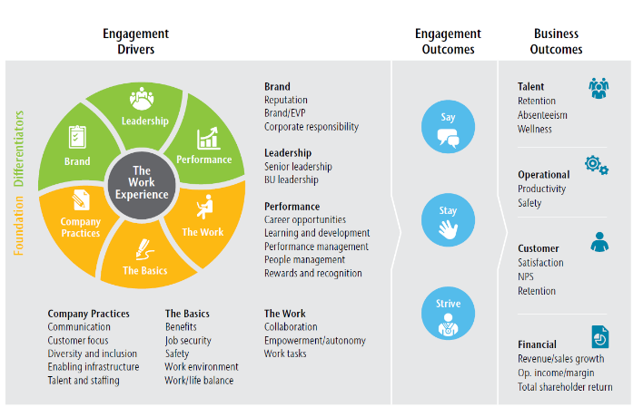
Figure 6: Aon Hewitt employee engagement model
- Recommendation
Given the high costs of labour, C&A should penetrate the Malaysian market by establishing online sales as well as establishing retail stores in the Malaysian market. The discouraging costs of workforce offer the company the opportunity to import textiles and apparel to the Malaysian market from other countries with lower production costs like China, Sri Lanka, Cambodia and India. Besides C&A should continue to apply its global HRM policy which has served the company to almost perfection. They should maintain their open and fair staff recruitment and selection process, reward management, training and development and performance appraisal and management techniques that have seen the company achieve below market average staff turnovers.

- Conclusion
To achieve the global sustainability strategy, C&A developed three pillar areas that have the most significant impact on their business; sustainable products, sustainable supply, and sustainable lives. C&A should penetrate to the Malaysian market to enhance its global market share and profitability. There are roughly over 795 Small and Medium Enterprises (SME) in the Malaysian textile industry. The market has a vast potential and is expected to grow to 154% by 2020. The country enjoys sophisticated textile systems but may end up failing due to the lack of knowledgeable and skilled labour. The shortage of skilled workforce is hindering the growth of the textile industry because many of the textile manufacturers shy away from committing to recurring orders to avoid setbacks due to labour shortage. Given the high costs of labour, C&A should penetrate the Malaysian market by establishing wholly owned online sales and retail stores in the Malaysian market.

- References

Altamony, H., Al-Salti, Z., Gharaibeh, A. &Elyas, T., 2016. The relationship between change management strategy and successful enterprise resource planning (ERP) implementations: A theoretical perspective. International Journal of Business Management and Economic Research, 7(4), pp.690-703.
Crinis, V., 2017. Global commodity chains in crisis: The garment industry in Malaysia. Institutions and Economies, pp.61-82.
Franco, M.A., 2017. Circular economy at the micro level: A dynamic view of incumbents’ struggles and challenges in the textile industry. Journal of cleaner production, 168, pp.833-845.
DeNisi, A.S. and Murphy, K.R., 2017. Performance appraisal and performance management: 100 years of progress?. Journal of Applied Psychology, 102(3), p.421.
Hawking, P. and Sellitto, C., 2018 Business Intelligence Project Implementation: A Retail Company Case Study in C-and-A.
Hickman, C.R. and Silva, M.A., 2018. Creating excellence: Managing corporate culture, strategy, and change in the new age. Routledge.
Hoole, C. and Hotz, G., 2016. The impact of a total reward system of work engagement. SA Journal of Industrial Psychology, 42(1), pp.1-14.
IDRIS, J. and RAHMAN, S.S.A., 2019. Analyzing Marketing Macro Environment of Islamic Tourism Industry in Malaysia.
Jha, B. and Kumar, A., 2016. Employee engagement: A strategic tool to enhance performance. DAWN: Journal for Contemporary Research in Management, 3(2), pp.21-29.
Lambert, J., 2016. Cultural diversity as a mechanism for innovation: Workplace diversity and the absorptive capacity framework. Journal of Organizational Culture, Communications and Conflict, 20(1), p.68.
Lee, K.L., Hassan, M.G. and Mohamed Udin, Z., 2016. The contribution of supply chain technology in Malaysian textile and apparel industry. Journal of Advanced Management Science.
Noe, R.A., Hollenbeck, J.R., Gerhart, B. and Wright, P.M., 2017. Human resource management: Gaining a competitive advantage. New York, NY: McGraw-Hill Education.
Sato, Y., Kobayashi, N. and Shirasaka, S., 2017. A Proposal of HR System’s Visualization based on Harvard Model, Life Cycle, and Organization Strategy and Management Type.
Shen, Y.C., Chen, P.S. and Wang, C.H., 2016.A study of enterprise resource planning (ERP) system performance measurement using the quantitative balanced scorecard approach. Computers in Industry, 75, pp.127-139.
Soesanto, R.P., Andrawina, L., Pertiwi, I.R. and Kurniawati, A., 2016, August.Relationship of Knowledge Management Cycle and the Performance from Human Customer and Organizational Perspective. In Knowledge Management International Conference (KMICe) Chiang Mai (pp. 416-420).
Swan, G.C.Y., Isa, M.B.M., Siddiq, M.S.B. and Razak, U.A.,2018 THE EXTERNAL ENVIRONMENT AND ITS EFFECT ON STRATEGIC MARKETING PLANNING: A CASE OF STARBUCKS MALAYSIA.
Udriyah, U., Tham, J. and Azam, S., 2019. The effects of market orientation and innovation on competitive advantage and business performance of textile SMEs. Management Science Letters, 9(9), pp.1419-1428.
Zarceno, J., 2017. ZarCen Training Model: Systematizing the Training and Assessment Process of Mechatronics Technology for the Optimization of the Skills Based Competency of Industry Workers. American Scientific Research Journal for Engineering, Technology, and Sciences (ASRJETS), 35(1), pp.67-85.
c-and –a .com sustainability.2019. Retrieved from http://sustainability.c-and-a.com/fileadmin/pdf-sustainability/globalsustainabilityreport2017-en.pdf
c-and –a. com career.2019. Retrieved from https://www.c-and-a.com/career/en/c-a-how-to-apply
Hofstede-insights.com . 2019. country comparisons Malaysia and neteherlands. retrieved from https://www.hofstede-insights.com/country-comparison/malaysia,the-netherlands/

